- Draw a labeled diagram of an ATX motherboard and mark at least 8 different slots and ports (such as RAM slots, PCIe slots, SATA ports, USB headers, CPU socket, power connector, etc.).
Answer :-
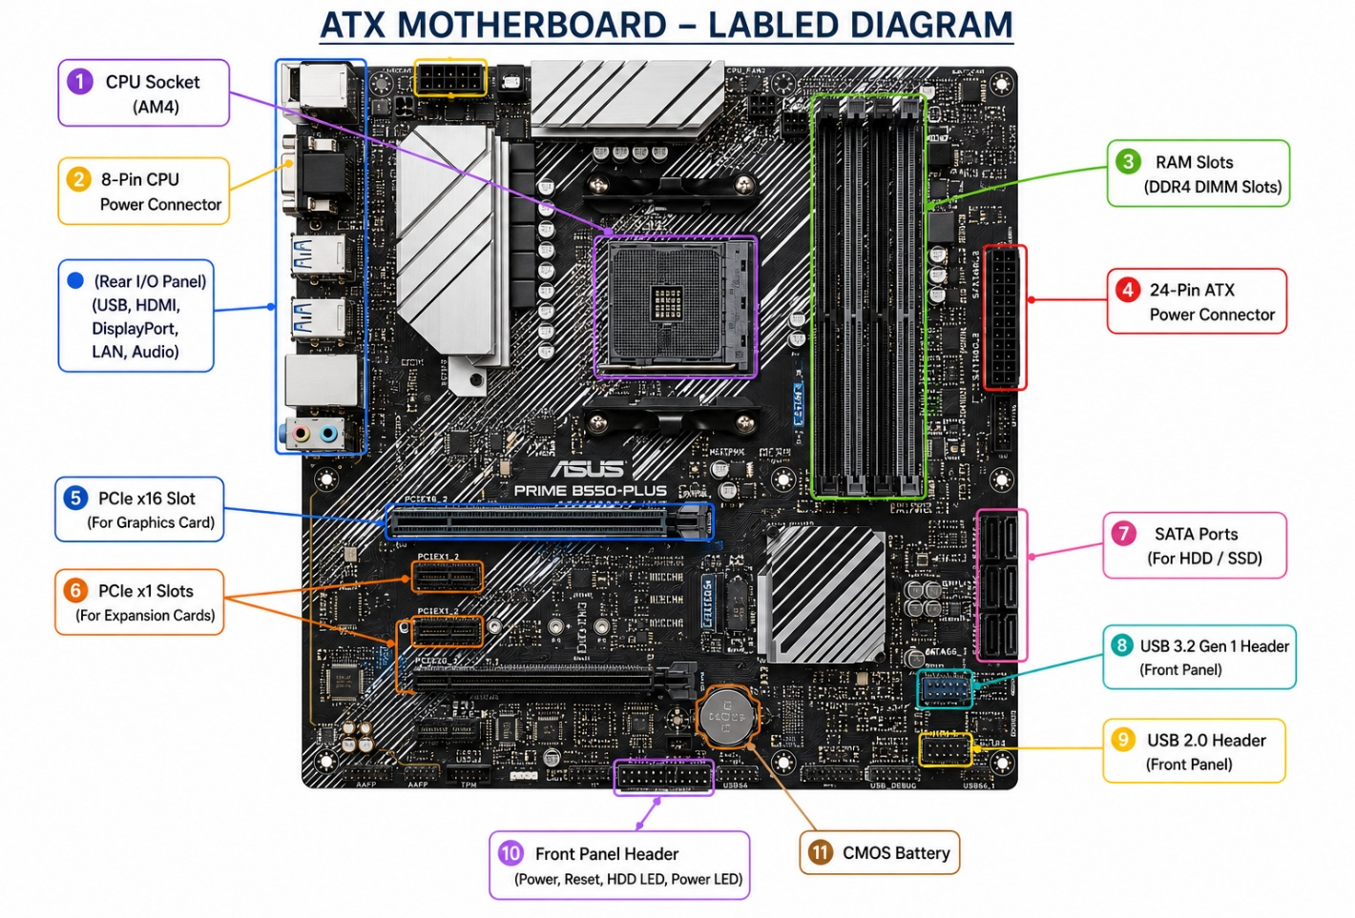

- Research and list 3 popular CPU socket types (for example: LGA1151, AM4, LGA1200) and name one compatible CPU model for each.
Answer :-
Popular CPU Socket Types and Compatible CPUs

CPU Socket Type :- LGA1151

Manufacturer :- Intel

One Compatible CPU Model :- Intel Core i7-9700K

Description : - Used in Intel’s 6th, 7th,8th, and 9th Generation Core Processors. Suitable For
Gaming and Everyday Computing.

CPU Socket Type :- AM4

Manufacturer :- AMD

One Compatible CPU Model :- AMD Ryzen 5 5600X

Description : - A widely used AMD socket that supports Ryzen processors from the 1000 to
5000 series. Popular for gaming and productivity.

CPU Socket Type :- LGA1200

Manufacturer :- Intel

One Compatible CPU Model :- Intel Core i5-10400

Description : - Designed For Intel’s 10th and 11th Generation Core Processors. Offers Good
Performance For Gaming and Office Work.

- Explain in your own words the primary functions of the CPU and the chipset on a motherboard and describe how they work together when you open a music app like Spotify.

Answer :-

CPU (Central Processing Unit)
The CPU is the main processor of the computer and is often called the "brain of the computer." It executes instructions, performs calculations, and controls all the tasks running on the system. The CPU is responsible for processing data and ensuring that applications run smoothly.

Chipset
The chipset is a group of electronic components on the motherboard that manages communication between the CPU and other hardware devices, such as RAM, SSD/HDD, USB ports, graphics card, and other peripherals. It helps the CPU access data from these components efficiently.

How the CPU and Chipset Work Together When Opening Spotify

When you open Spotify on your computer, the CPU receives the command to launch the application and start processing its instructions. At the same time, the chipset helps transfer the required data from the SSD/HDD to the RAM and enables communication with devices such as the sound card, speakers, keyboard, mouse, and internet adapter. Together, the CPU and chipset ensure that Spotify opens quickly, loads your music, and plays audio smoothly without interruptions.

- Find a clear photo of a real motherboard (from the internet or your own device) and identify at least 5 different ports or slots by circling them and labeling each one.

Answer :-

